Dear (Sir / Ma’am),

As your business is a vital part of our community, I would like to share an opportunity that may warrant your favorable consideration. Each year our church has helped send many of our teenagers and young people to Christian Camp and on a mission trip. This has been a great help in building Christian character and values in our young people, as well as preparing them to meet the many challenges that face today’s youth.

To offset the substantial expense of this ministry, and to provide some of our area businesses with the opportunity to support a worthwhile cause while advancing community relations, we are asking for your support of our 8th Annual Tidewater Baptist Youth Benefit Golf Tournament, scheduled for 20 September 2014 at Chesapeake Golf Club in Chesapeake, VA.

Funds raised by this tournament will help teenagers attend our annual trip to the Wilds Christian Camp in North Carolina. Additionally, these funds will support our Youth Group’s annual mission trip. This year we are trying to raise enough money to send our senior teens on an overseas mission trip. They are headed to England, a country once in revival that is now greatly influenced by unbelievers. The teens will need $18000 total for this trip and all monies raised through these sponsorship letters will go directly to the teens’ accounts!

We have three levels of sponsorship – gold, silver, and bronze. For a Gold Sponsorship of $500, you will receive a complimentary foursome to participate in all activities for the day including golf and food and beverages. You will also be listed as a primary sponsor, including a large banner, a listing in our program and literature, as well as having a prominent sponsor sign located on the 1st tee box. A Silver Sponsorship of $250 includes all of the gold benefits except the complimentary foursome. A Bronze Sponsorship of at least $100 will also be listed in our program and literature with a sponsor sign on one of the tee boxes.

With this support, your business can be a partner in potentially making a difference in a young life. Your donation is tax-deductible, and all proceeds will go toward the Tidewater Baptist Youth Ministries Christian Camp and Missions program. No funds are used for tournament administration.

Thank you very much in advance for your favorable consideration of this worthwhile event. If you have any questions or need any further information please call our offices at 757.545.7272.
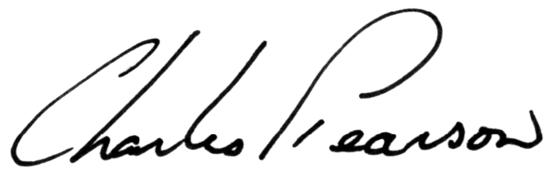
C. K. Spain Charles Pearson
Golf Chairman, Tidewater Baptist Church Pastor, Tidewater Baptist Church
Tidewater Baptist Teens Golf Tourney 2014
Sponsor Sign-Up Sheet

Business Name:

Business Address:

Business Phone:

Point of Contact Name:

Bronze Sponsor (minimum $100.00 donation)

Includes: T-Box Sign and Four-Line Business Advertisement in Tournament Program.
Name of Business as it will appear on T-Box Sign___________________________________________________________________

Line one of Program Advertisement

Line two of Program Advertisement

Line three of Program Advertisement

Line four of Program Advertisement

Silver Sponsor (minimum $250.00 donation) (Bronze Sponsor + Large 2’ x 6’ Banner)

Line one on banner______________________________________________________

Line two on banner______________________________________________________

Line three on banner_____________________________________________________

Gold Sponsor (minimum $500.00 donation) (Silver Sponsor+) Names_______________

Complimentary Golfer __________________________________ Complimentary Golfer ____________________________________

Complimentary Golfer __________________________________ Complimentary Golfer ____________________________________

Tourney Partner (other donations)

Includes: Two-Line Business Advertisement in Tournament Program.

Line one of Program Advertisement

Line two of Program Advertisement

Note: All donations are tax deductible. You will receive a tax receipt from Tidewater Baptist Church for all contributions.

Please make checks payable to: Tidewater Baptist Church Teens – Memo Line: Youth Golf Tourney

Thank you very much for your support.

